Python Assignment
Note
GIThub link :https://github.com/nilaybudhe/nilaybudhe

1. 1. Grade Checker
Take a score as input and print the grade based on the following:
90+ : "A"
80-89 : "B"
70-79 : "C"
60-69 : "D"
Below 60 : "F"
here we used a basic if else statement to carry out marks and all
Answer: 1. We have write program using if else statement. Based on student mark, you will get the result in grade.
I will add the program file on github. Below are screenshot code with result.
. 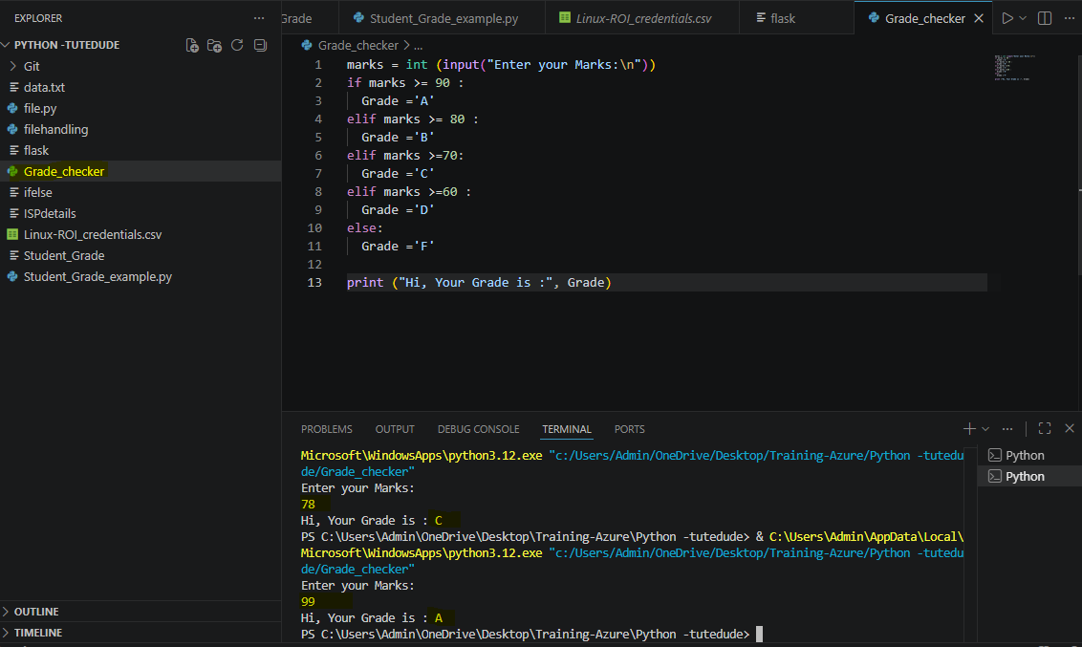

2. Student Grades
Create a dictionary where the keys are student names and the values are their grades. Allow the user to:
Add a new student and grade.
Update an existing student’s grade.
Print all student grades.
Used dictionary and basic operations. Using if else:
Answer:1. I have write program menu driven using if else statement.
- I have 4 option 1. You can add the information, update the information and display all the information , and exit from program.
- Below screenshot shows coding with output please find below SS.
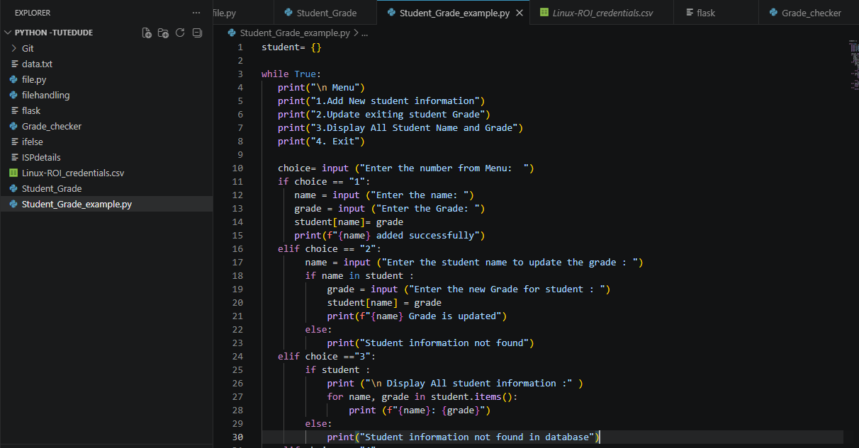

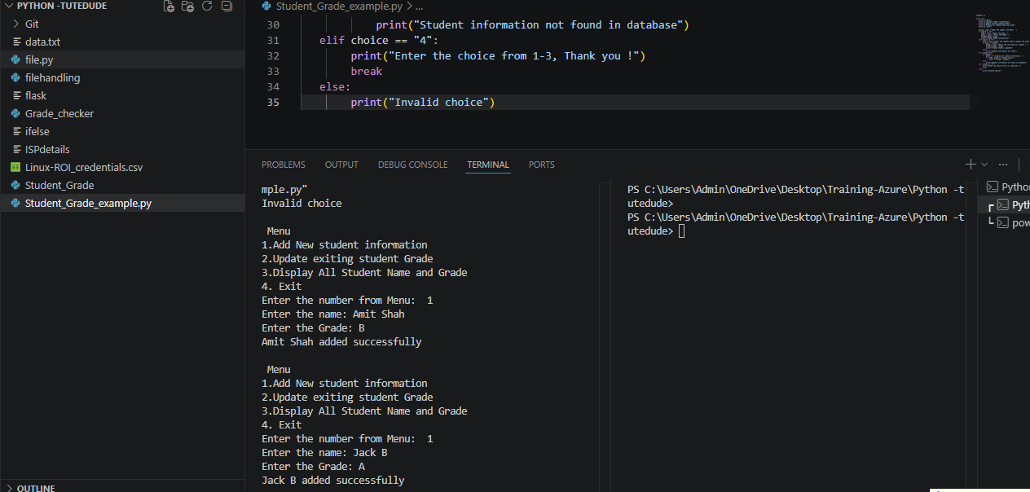
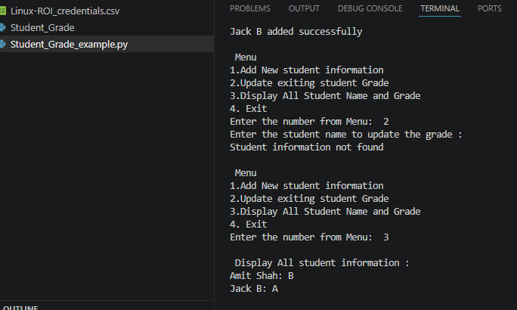
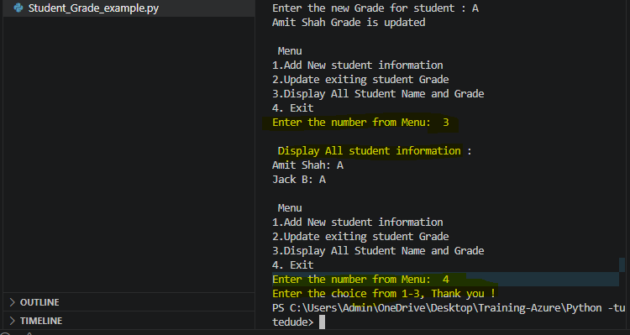

3. 3.Write to a File
Write a program to create a text file and write some content to it.
Using file functions like write and open.
Answer: 1. Function f , open the data.txt file r + means read and write the file
data = f. read( ) information stored in Data
f. read () read the information from file
Display the information using print (data )
We have allowed for this file append the information
f.write () update the new information in data.txt
f.close() --. Closed the file

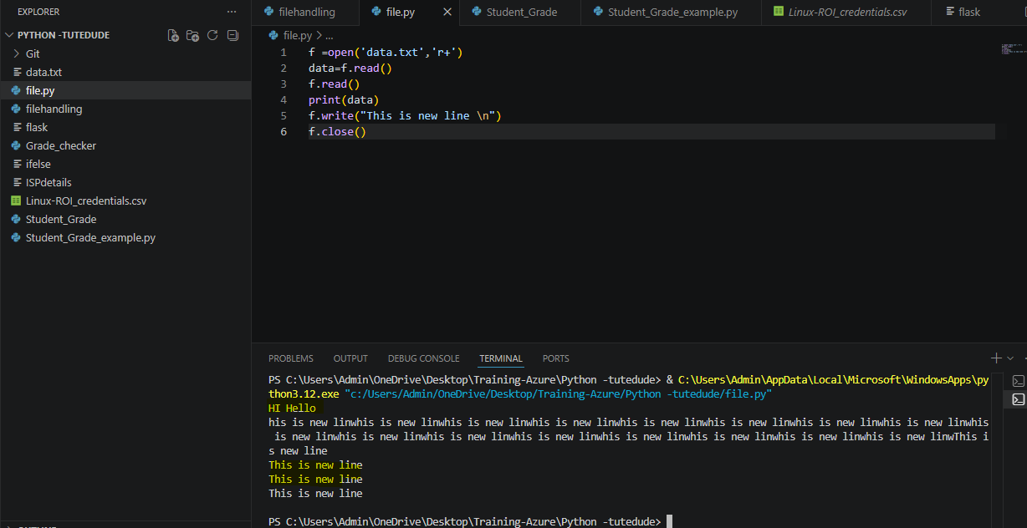

4. Read from a File
We used open in read mode and file.read to read and print to display.
Answer:
r- read only
f.read() read the data which is on file

